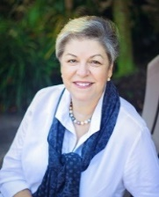 | Silvia López  Children’s Author  http://www.silvialopezbooks.com

AUTHOR VISIT GUIDELINES

Thank you for your interest in scheduling an author visit for your school!
I don’t charge for school visits, whether in person in Miami-Dade County, or virtual. If the school is not within Miami-Dade County, please contact me through my website.

PRESENTATIONS
For in-person visits, I do an interactive PowerPoint presentation using a projector or smartboard, if it’s available. For virtual visits, I like to be able to share the presentation as well. Depending on the book, I read it aloud, read from it, or discuss it. I also talk about the authoring/illustration process. I can see classes individually, or several at once, from 30-50 minutes, depending on the book.

BOOK PURCHASES – SIGNINGS - FUNDRAISERS
Purchases are not necessary for my visit
If the school is local and students wish to order books, I’ll provide an order form to be sent home. I’ll return to the school later and deliver the personalized copies. If not, the school can pre-order copies and I will sign them during the visit. Details can be worked out.
I’m always happy to read aloud and do signings during local special events, like family reading nights or book fairs.

Thank you! Looking forward to a visit!

